Template for the story editing
For a good implementation in the Blue Arrow authoring tool your need a good story. But the story is not enough!
You need to have a clear idea of all the steps of your story, what are the dialogs and then which audios you have to record, or which audios your students will record. Finally, you need to know which tangible object you need for the execution.
In order to do this task, first of all create your story and your dialogs with all of the steps filling this form. This is a scaffolding that could help you to create your story!
A story line is like this:
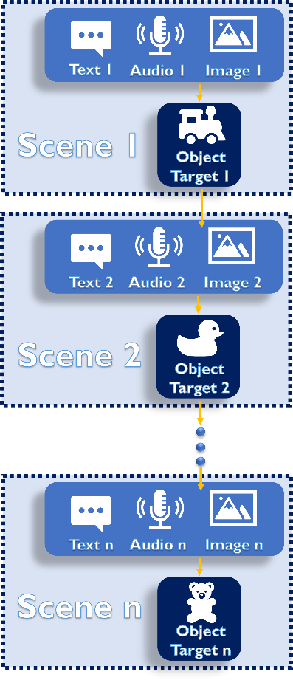
Download and insert your data and info
Step Number | 1
Step Name
Text 1
Image 1
Negative Feedback
Tangible object target
How you suppose to create/gather this material

Step Number | 2
Step Name
Text 2
Image 2
Negative Feedback
Tangible object target
How you suppose to create/gather this material

Step Number | 3
Step Name
Text 3
Image 3
Negative Feedback
Tangible object target
How you suppose to create/gather this material
Step Number | 4
Step Name
Text 4
Image 4
Negative Feedback
Tangible object target
How you suppose to create/gather this material

Step Number | 5
Step Name
Text 5
Image 5
Negative Feedback
Tangible object target
How you suppose to create/gather this material

Please add as many steps as you need

